# Working with Sinatra

# SINATRA

1. CREATING A DATABASE
2. Create a database file – NEVER look at this. If you delete it, it’s gone forever.
3. Create a .sql file – call it the name of the table you want.
4. In the .sql create the table with the columns that you need in the them:

CREATE TABLE person (

id INTEGER PRIMARY KEY, ### AUTOINCREMENT GOES SOMEWHER HERE

first_name TEXT,

last_name TEXT,

age INTEGER

);

1. Back in the console, need to run the database. Do this using

sqlite3 desired_database_name.db < add_this_table.sql

sqlite3 database.db < person.sql

This line will create the database.db file if necessary, and if not - it will just add whatever is defined in the .sql file specified. It imports the details from the .sql into the database.db.

1. Check it’s there. Do this in the CONSOLE
   1. type in sqlite3 database.db and hit enter in the terminal. This will open up a direct line to the database in the current folder
   2. type .schema - shows the current tables.

## Working with the DB from the Console

### Importing the database

1. Make sure you’ve run the database. Do this using

sqlite3 desired_database_name.db < add_this_table.sql

sqlite3 database.db < person.sql

This line will create the database.db file if necessary, and if not - it will just add whatever is defined in the .sql file specified. It imports the details from the .sql into the database.db.

1. Check it’s there. Do this in the CONSOLE
   1. type in sqlite3 database.db and hit enter in the terminal. This will open up a direct line to the database in the current folder
   2. type .schema - shows the current tables.

## Importing the sql file

can import that SQL into the database –

sqlite3 database_name.db < insert_stuff.sql

## ADD RECORDS – “Create.SQL” file + SQL command + import into DB – using SQLlite3 only

1. Create a create.sql file.
2. Copy current database schema into that file and comment out.
3. User SQL to add data to it.

INSERT INTO person (id, first_name, last_name, age) VALUES ( 0, "Zed", "Shaw", 37 );

-- We don't need to tell the attributes though, it can look just like this...

INSERT INTO person VALUES (0, "Zed", "Shaw", 37);

## Read records – READ.SQL file + Sql commands

1. Create read.sql file
2. Use the right commands in the SQL file

-- SELECT what FROM what_table;

-- SELECT what FROM what_table WHERE options;

SELECT * FROM person; -- this will select all attributes and all records from the person database

SELECT name FROM person; -- only show the name attributes

SELECT * FROM person WHERE first_name == "Zed"; -- show all attributes from records in the person database where the first_name is "Zed"

1. Add it to the database via the CONSOL

sqlite3 database_name.db < insert_stuff.sql

## UPDATE STEP – create update.sql file + SQL command + add to DB via the console

UPDATE table SET attribute_name = attribute_value WHERE attribute_name = attribute_value;

UPDATE person SET first_name = "WOLF" WHERE first_name = "Zed";

## DELETE STEP – create delete.sql file + SQL command + add to DB via the console

DELETE FROM what_table WHERE what_attributes = what_value;

DELETE FROM person WHERE first_name = "Zed"; -- Delete all records in the person table where the first_name is equal to "Zed"

# Overall structure of CRUD application Using sinatra

In terms of actual structure of an application, this is the structure of a CRUD application. 7 views for all of this! The #new and the #edit are just ways to show the actual form.

### Files

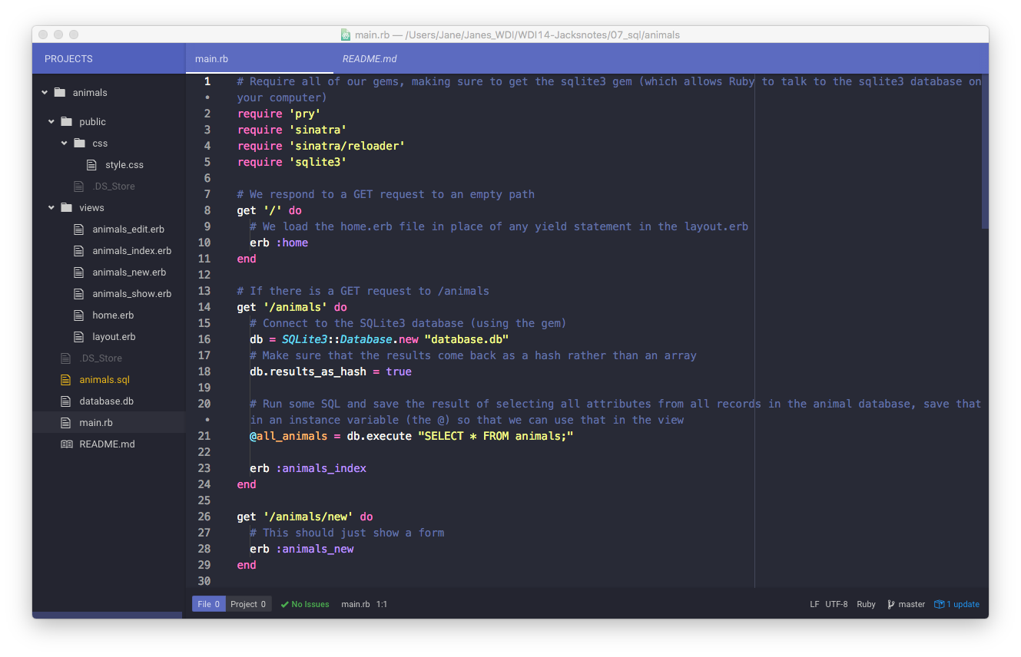

## COMMANDS

| STEP |  |  |  | **File name** |  |
| --- | --- | --- | --- | --- | --- |
|  | VERBS | **URLS** | Line in main.erb | **SQL file name** | **SQL COMMAND** |
| CREATE | POST | /butterflies |  | #create | INSERT |
|  |  | /butterflies/new |  | #new |  |
| READ | GET | /butterflies |  | #index | SELECT |
|  | GET | /butterflies/:id |  | #show | SELECT |
| UPDATE | POST | /butterflies/:id |  | #update | UPDATE |
|  |  | /butterflies/:id/edit |  | #edit |  |
| DELETE | (Delete) | /butterflies/:id |  |  | DELETE |  |

CRUD is the foundation of most applications on the web, it is the thing that powers it! Important to get the principles of it.